VBugs Chapter 1 Worksheet

|  |
| --- |
| **Name:**  *Solutions* |
| **Home Room:** |

Question 1

What is happening on your SwinGame screen? Describe the output below:

There is a black background, light blue “Hello World!” in the top left corner text and a red rectangle underneath the text.

Question 2:

* 1. What purpose do comments serve in code?

Comments allow the programmer to make notes to themselves or whoever might view the code in the future describing what the code is doing. Also you can use them to stop a particular line of code from executing.

* 1. What symbol do you use to make something a comment?

‘ a single quotation

* 1. Why do you think we might use NS diagrams to represent code?

These allow you to think logically and plan you code before you implement it reducing the risk of errors.

* 1. What would happen to the loop the “Do Until” condition was never met?

The game would just keep looping infinitely.

Exercise1: *Reading the code*

Line 21

1. Which line contains the code that tells the computer to

draw text on the screen?

Line 18

1. Which line does contain the code that tell a computer to draw

a rectangle on the screen?

Start-13, end -27

1. Where (line number) does the game loop start and end?

Exercise 2: *Changing the text*

Change the text "Hello World!" to "Hello *Your Name*!"

Write the code below that you changed to make this happen:

|  |
| --- |
| Answer:  Text.DrawText("Hello Your Name!", Color.Aqua, GameFont("ArialLarge"), 100, 150)  …  'Draws text "Hello World"        'Refreshes the Screen and Processes Input Events  … |

Exercise 3: *Changing the color*

1. Change the color of the text to Color.GreenYellow.

Write the code below that you changed to make this happen:

|  |
| --- |
| Answer:  Text.DrawText("Hello Your Name!", Color.GreenYellow, GameFont("ArialLarge"), 100, 150)  …  'Draws text "Hello World"        'Refreshes the Screen and Processes Input Events  … |

* 1. Change the color of the rectangle to Color.Blue.

Write the code below that you changed to make this happen:

|  |
| --- |
| Answer:  Graphics.FillRectangle(Color.Blue, 20, 150, 500, 50)  …  'Draws red rectangle    'Draws text "Hello World" |

1. Change the background color to Color.LightBlue.

Write the code below that you changed to make this happen:

|  |
| --- |
| Answer:  SwinGame.Graphics.ClearScreen(Color.LightSkyBlue)  …  'Clears the Screen to Black      'Draws red rectangle  … |

Exercise 4: *Locations on the screen*

1. 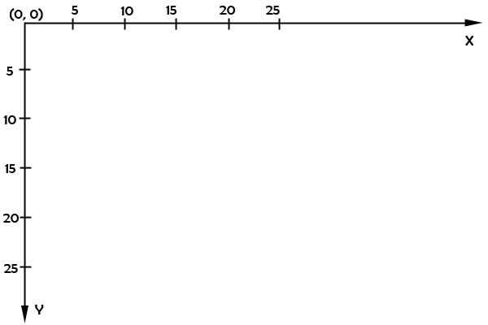In the area below draw a small rectangle with coordinates X = 15 and Y = 5 by hand.
2. In the area below draw the text “Hello Your Name” at X = 5, Y = 20.



Hello *Your Name*

Exercise 5: *Changing drawing locations*

1. Change the location of the text; put it in the middle of the screen.

Write the code below that you changed to make this happen:

|  |
| --- |
| Answer:  Text.DrawText("Hello Your Name!", Color.Aqua, GameFont("ArialLarge"), 100, 150)  'Draws text "Hello World"      'Refreshes the Screen and Processes Input Events  … |

1. Change the location of the rectangle; put it under the text.

Write the code below that you changed to make this happen:

|  |
| --- |
| Answer:  Graphics.FillRectangle(Color.Blue, 100, 250, 500, 50)  'Draws red rectangle      'Draws text "Hello World" |

Exercise 6: *Size of an element*

1. In the area below draw a rectangle with width = 5, height = 10 at the position X = 0, Y = 5.



1. In the area below draw a rectangle with width = 10, height = 5 at the position X = 5, Y = 10.



Exercise 7: *Draw an element with the new size.*

Change the size of the rectangle to width = 630 and height = 20.

Write the code below that you changed to make this happen:

|  |
| --- |
| Answer:  Graphics.FillRectangle(Color.Blue, 100, 250, 630, 20)  …  'Draws red rectangle      'Draws text "Hello World" |

Exercise 8: Draw a smiley face

1. Draw a yellow circle on the screen – “face”. Use:

Graphics.FillEllipseOnScreen(Color, Xpos, Ypos, Width, Heigh)and the following dimensions:

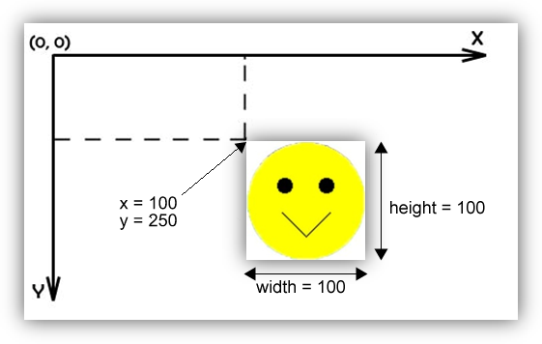

1. Draw the eyes – two black circles inside the yellow circle. Use the same sub call to draw, i.e.:

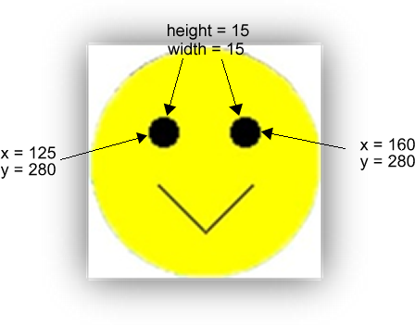

1. Draw the “smile” on the screen.

Tell the computer to draw two lines which are connected at the bottom, inside the yellow circle. To do so, use:

Graphics.DrawLineOnScreen(Color, XPosStart, YPosStart, XPosEnd, YPosEnd) i.e.:

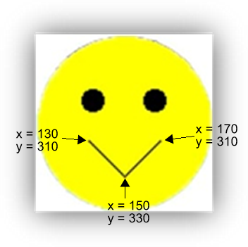

*Put the code you entered to draw the smiley face this below:*

|  |
| --- |
| Graphics.FillEllipseOnScreen(Color.Black, 125, 280, 15, 15)  Graphics.FillEllipseOnScreen(Color.Black, 160, 280, 15, 15)  Graphics.FillEllipseOnScreen(Color.Yellow, 100, 250, 100, 100)  Graphics.DrawLineOnScreen(Color.Black, 130, 310, 150, 330)  Graphics.DrawLineOnScreen(Color.Black, 170, 310, 150, 330)  'Draw yellow circle on the screen – “face”.      'Draw eyes – two black circles inside the yellow circle      'Draw “smile” on the screen. |